SQL ASSIGNMENT 8

Q1. Write an SQL query to fetch intersecting records of two tables.

**Solution:**

Step-1. Since workers and worker2 table contains same records. Let’s add few more records to workers table to obtain the intersecting and non-intersecting records.

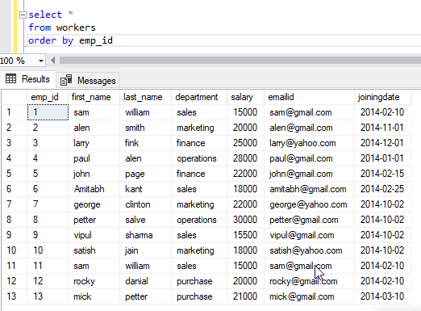

Select * from worker

Intersect

Select * from worker2

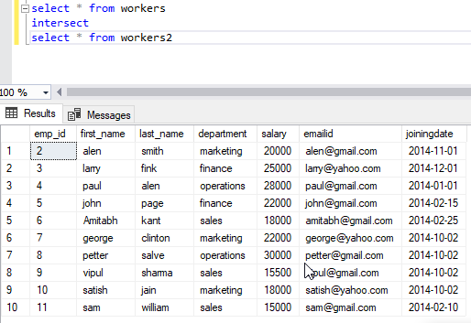

Q2. Write an SQL query to show records from one table that another table does not have.

**Solution:**

Step-2. Select * from worker

Where emp_id not in ( select emp_id from workers2);

